Mathematics Essential Name: _____Solutions____________

Task 2.2 – Unit 2

Assessment type: Response - Skills

Conditions:

Time for the task: 30 minutes

In class, calculator permitted

Marks: ______/25

Task weighting:

2% of the school mark for this unit

_______________________________________________________________________________

Question 1:
(5 Marks)
- Write 8.3% as a decimal 0.083

- Round 12456 to the nearest 100 12500

- 22mL = _0.022_____ L

- Calculate the area of a 4m by 50cm rectangular window 2m² or 200cm²

- If someone ran 1500m in 5 minutes what is their average speed? 300m per min or 18 km/hr

Question 2: (3 Marks)

Write the missing word.

- The mode is the most _Common______ value.

- The median is the __Middle______ value.

- To calculate the _Mean____, you add up all the values and divide by the number of values.

Question 3:
Find the mean, median, mode and range of the following data set. (2,2,1,1, marks)
10,66,23,45,78,9,86,32,11,66
- Mean: 42.6

- Median: 38.5

- Mode: 66

- Range: 77

Question 4: (1,1, 6 Marks)

The running time, in minutes, of 16 movies at the cinema were as follows:
123 110 98 120 102 132 112 140 120 139 42 96 152 115 119 12
- Order the above data set on the line below

12, 42, 96, 98, 102, 110, 112, 115, 119, 120. 120, 123, 132, 139, 140, 153,
Q2
Q3
Q1

- Find the range. ________140_____________________

- Find and label under the line above the:
- the median (Q2) _____117________________________

- the lower quartile (Q1) _____100_____________________

- the upper quartile (Q3) ________127.5____________________

- the interquartile range (IQR). _______32_____________________

Question 5:
A survey is conducted of the number of people in different families. The results are shown.
(3 marks)
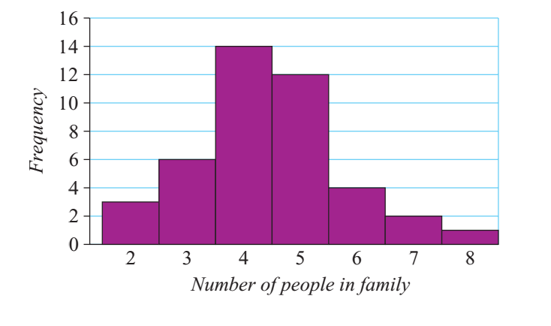

- What is the most likely number of people in a family, on the basis of this survey? 4

- How many people responding to the survey said they had a family of 6? 4

- What is the least likely number (from 2 to 8) of people in a family, on the basis of this survey? 8

